Network Task

Task Description:
1.Get me the IP address of a particular domain (guvi.in). How do I find my CPU/memory usage of my server? Test the connectivity between 2 nodes?
2.I have deployed an application in guvi.com:9000, and logs show my app is running, but I’m unable to view the page. Check whether my port is open or not?

1. Get me the IP address of a particular domain (guvi.in). How do I find my CPU/memory usage of my server? Test the connectivity between 2 nodes?
1.1. Get IP address of a domain (guvi.in)
- nslookup and dig are DNS tools used to resolve a domain name into its IP address.
- When you run this command, it queries the DNS server and returns the IP address mapped to guvi.in
Command 1: nslookup guvi.in
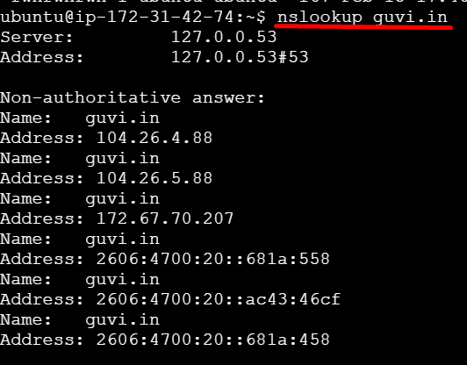
Command 2: dig guvi.in
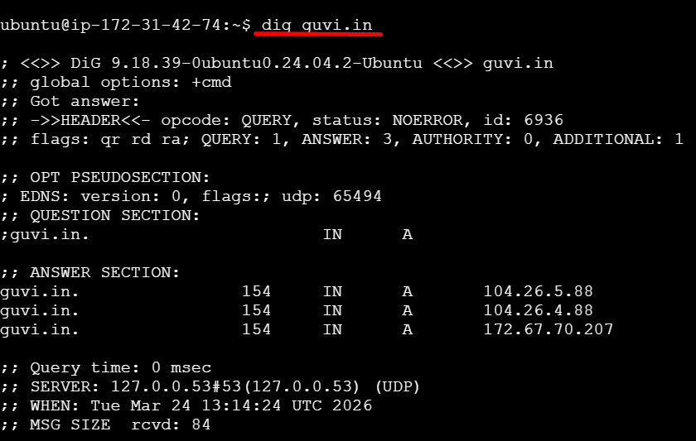

1.2. Check CPU and Memory usage:
Command1 : top
top: Shows real-time CPU and memory usage along with running processes.

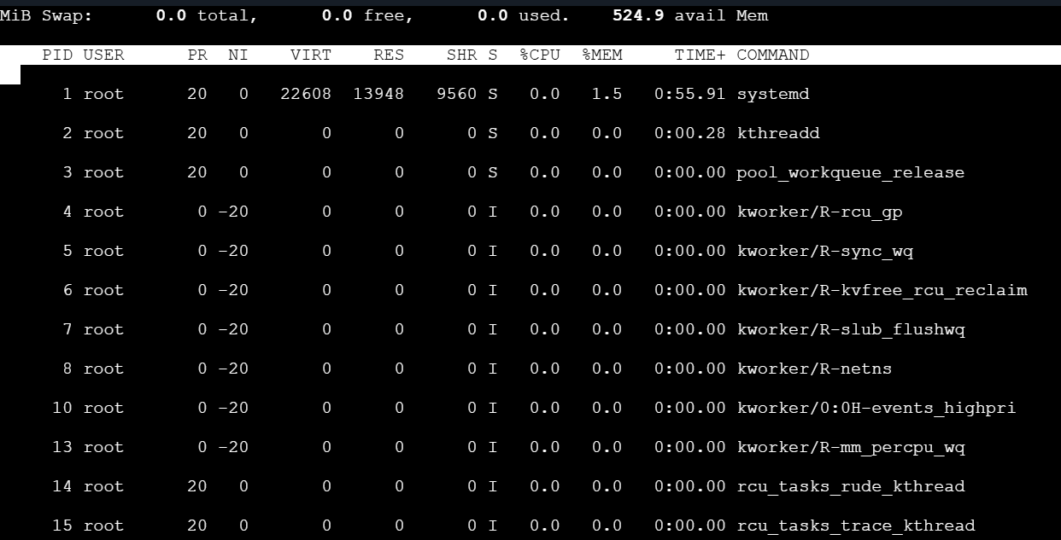

Command 2: htop
htop: Improved version of top (user-friendly, if installed).
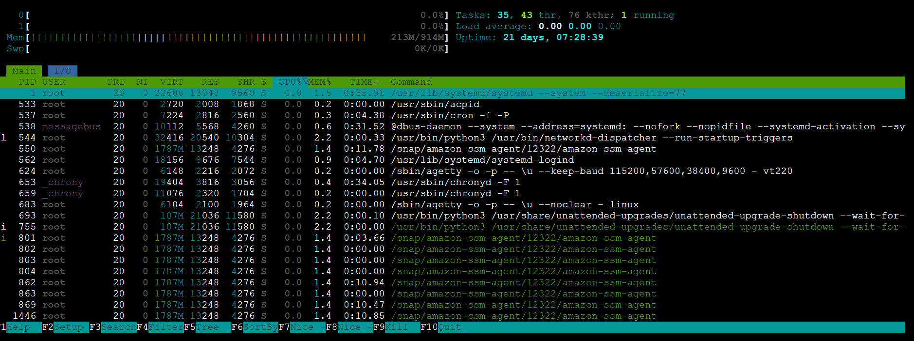
Command 3: free -m
free -m: Displays memory usage in MB (total, used, free).

1.3. Test connectivity between two nodes
Command1 : ping <IP_or_hostname>
Description:
- ping checks whether another server/node is reachable.
- It sends ICMP packets and waits for a response.
- If replies are received → connectivity is OK.
- If not → network/firewall issue.
Command 2: telnet <IP> <port>
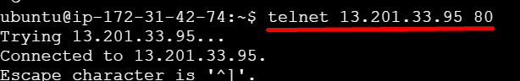
Command 3: nc -zv <IP> <port>
Used to test connectivity to a specific port.

2.I have deployed an application in guvi.com:9000, and logs show my app is running, but I’m unable to view the page. Check whether my port is open or not?
2.1. Check from your server (application side)
Command 1: netstat -tulnp | grep 80
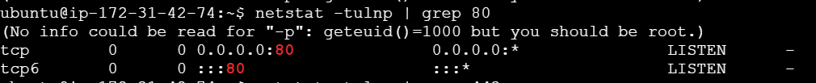
Command 2: ss -tulnp | grep 80
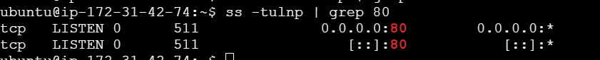
Description:
- These commands check if your application is actually listening on port 80.
- If you see LISTEN, your app is running correctly on that port.
2.2. Check if port is open from server
Command 1: telnet guvi.com 80
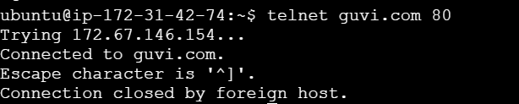
Command 2: nc -zv guvi.com 80

Description:
- Verifies whether the port is reachable from outside.
- If connection fails → port may be blocked.
2.3. Check firewall rules
Command 1: sudo ufw status
Command 2: sudo ufw allow 9000
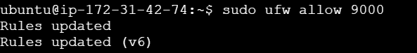
Command 3: sudo iptables -L -n
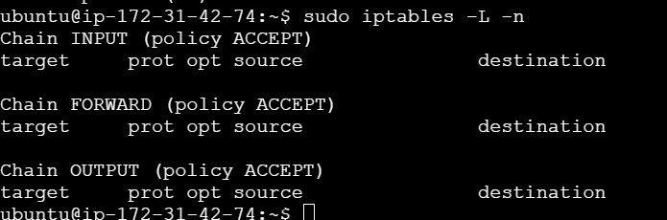

2.4. Check cloud security group (if using AWS/Azure)
Description:
- Ensure port 9000 is allowed in:
  - Security Groups (AWS)
  - NSG (Azure)
- Rule should allow:
  - Port: 9000
  - Source: 0.0.0.0/0 (or your IP)

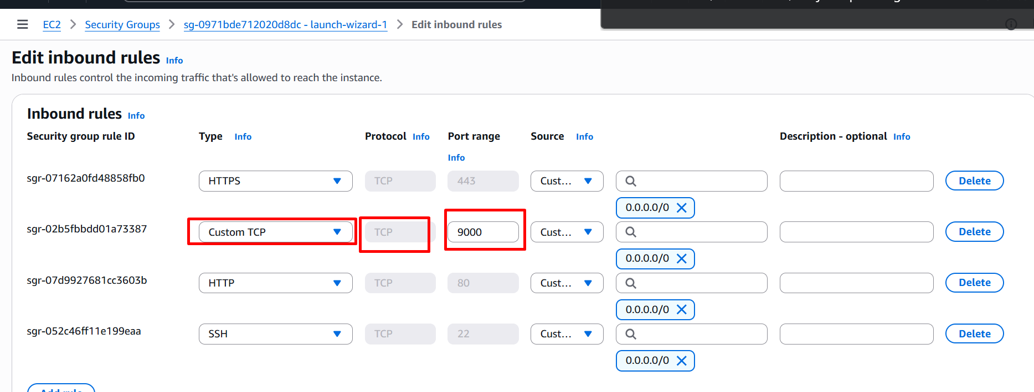

Test locally:
curl http://localhost:9000
Description:
- Confirms whether the application is working internally.
- If it works locally but not externally → network/firewall issue.

